

|  |  |
| --- | --- |
| **IDS 462 STATISTICAL SOFTWARE FOR BUSINESS** | |
| **HOMEWORK 3 – Part 2** | |
|  | **TEAM MEMBERS**: |
| 1. | Harish Visweswaraiya |
| 2. | Sriram Ravi |
| 3. | Vinodh Sankaran |
| 4. | Balachandhar Chekka Narayanasame |

Part 2

Air Carrier_Details

Code

data air_carrier_rates;

infile '/folders/myfolders/SAS_HW3/rates.dat'; input Origination :$3.

Destination :$3.

Range_of_Flight $ Cargo_Rate Passenger_Fare Category_of_Flight $;

new_cargo_rate = Cargo_Rate + 0.50;

If Range_of_Flight = 'SHORT' then new_pass_fare = ((0.08*Passenger_Fare)+(Passenger_Fare)); Else if Range_of_Flight = 'Medium' then new_pass_fare =

((0.1*Passenger_Fare)+(Passenger_Fare));

Else new_pass_fare = ((0.12*Passenger_Fare)+(Passenger_Fare));

Run;

Output Data

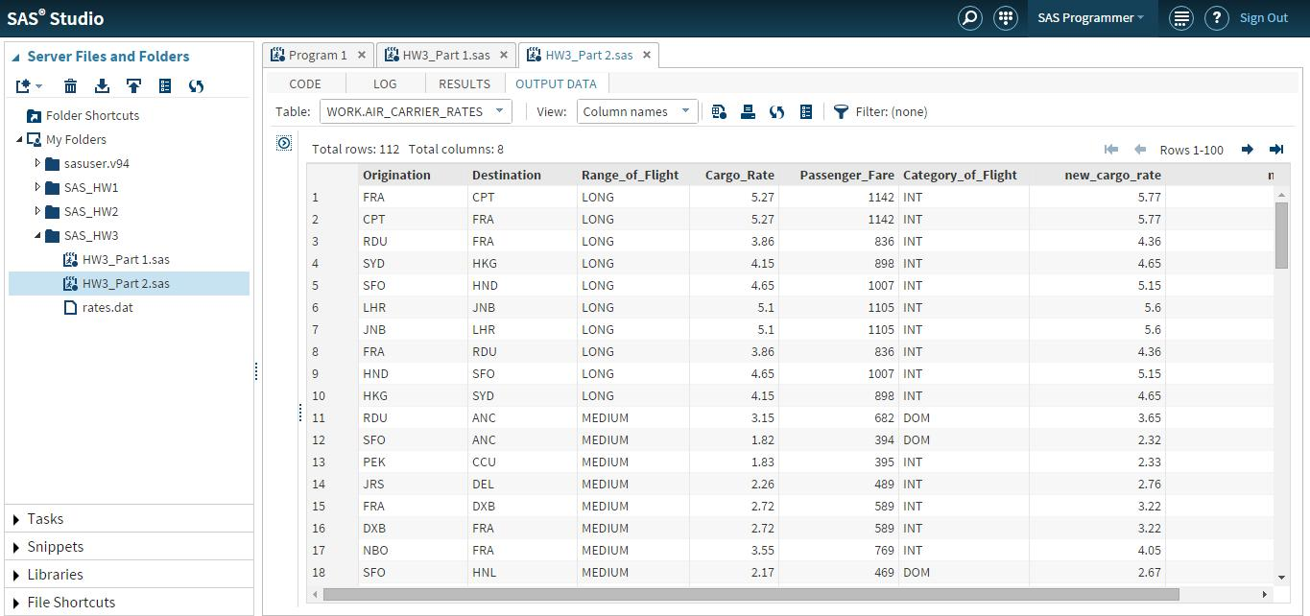

Report 1 – Listing of all files with new cargo rates

Code

/* Report 1 */

proc print data=air_carrier_rates (keep = Origination Destination new_cargo_rate); title "Flight listings with new cargo fare";

Run;

Output Data

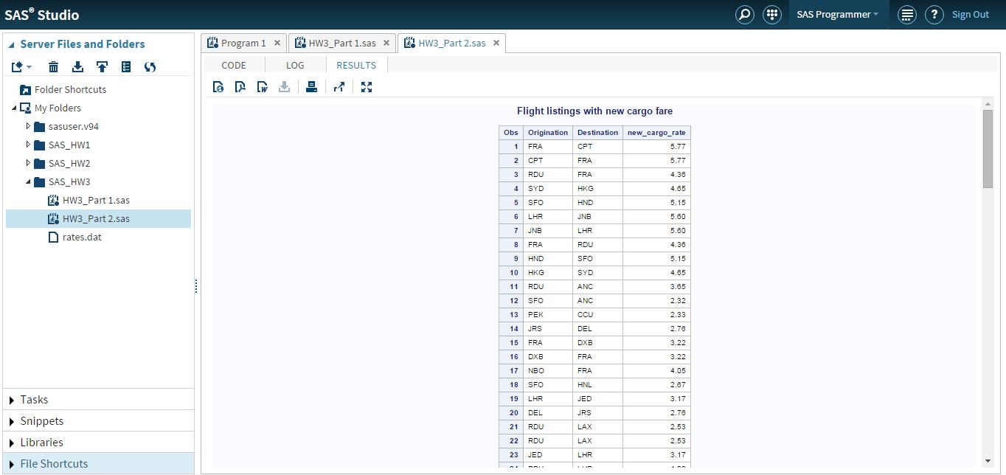

Report 2 – **Comparison between the average current passenger fare and the average new passenger fare for** **the domestic and international flights**

Code

/* Report 2 */

proc sort data=air_carrier_rates out=air_carrier_rates_sort; by category_of_flight; Run;

proc means data=air_carrier_rates_sort (keep=category_of_flight passenger_fare new_pass_fare)mean; BY category_of_flight;

output out=air_carrier_rates_comp mean=Average; run;

Output Data

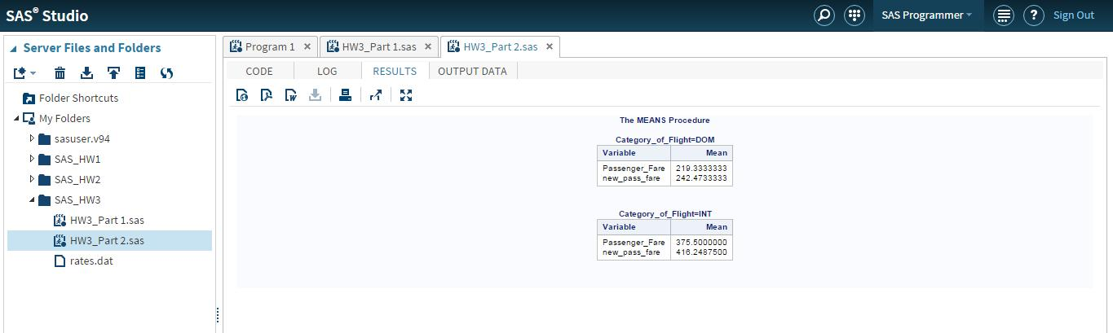

Report 3 – **A breakdown of the frequency and percentage of domestic flights and international flights**Code

Code

/*Report 3 - Frequency and Percent for Domestic and International Flights*/ proc freq data=air_carrier_rates;

tables category_of_flight/out=air_carrier_rates_freq norow nocol nocum; run;

Output Data

